CHAD MICHAEL COLLINS

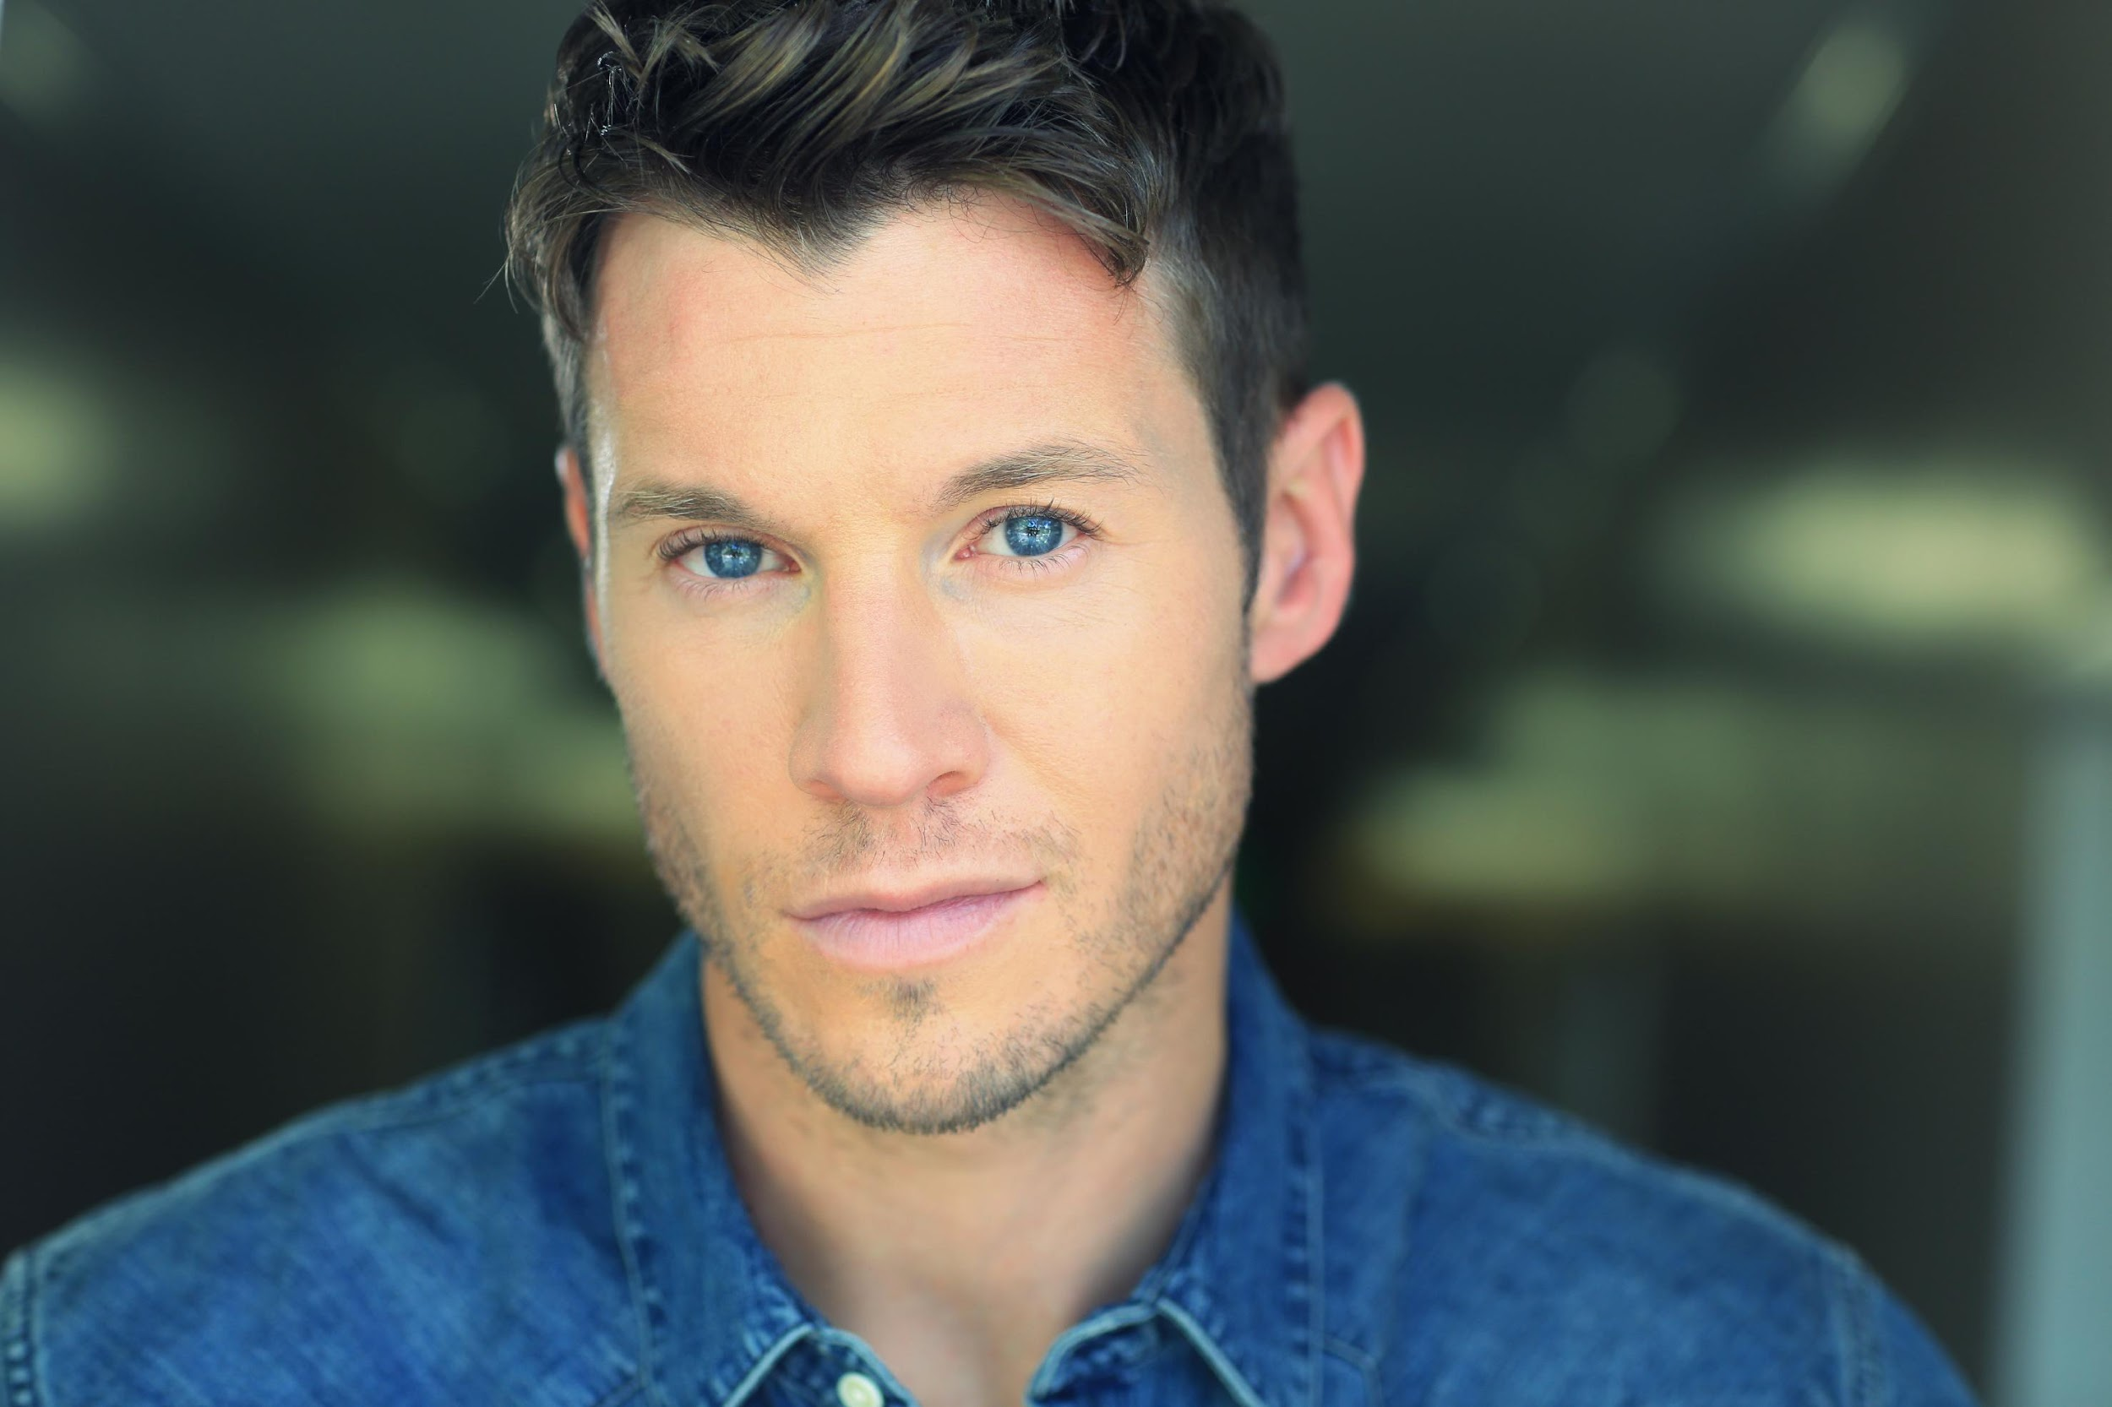
Born and raised in upstate New York, actor Chad Michael Collins landed in Los Angeles after being offered a job in entertainment public relations during college. But since the day a successful talent manager convinced him to try an acting class several years ago, Collins has gone on to amass over two dozen major television and film credits.

Collins is best known for his franchise-starring role in Sony’s reboot of their internationally renowned SNIPER films. Collins first appeared in SNIPER: RELOADED (2011), playing the son of Tom Berenger’s original legendary Marine sniper. The film co-starred Billy Zane, and Collins reprised his lead role as ‘Sgt Brandon Beckett’ in SNIPER: LEGACY (2014) alongside co-stars Tom Berenger, Dennis Haysbert and Mercedes Mason. Sony released SNIPER: GHOST SHOOTER, Collins' third film in the franchise with co-stars Zane and Haysbert, in 2016, and on October 3rd, 2017, Collins once again starred as the lead in the latest SNIPER installment, SNIPER: ULTIMATE KILL, which reunited both Billy Zane and Tom Berenger – the stars of the original SNIPER (1993) film – together onscreen again for the first time in 25 years.

On May 14th, Collins will be seen in the starring lead role for the action-horror-western film HIGH MOON (www.HighMoontheMovie), co-starring Sean Patrick Flanery from Director Josh Ridgway. Collins plays ‘Colt’, a werewolf slayer from the old west mysteriously transported to modern times to battle a vicious gang of bloodthirsty "howlers" ravaging a small town. Shot in and around Dallas, Texas, the throwback John Carpenter-esque film will release on digital, followed by DVD/Blu-ray in July. Collins will also be seen in the new AMC’s Shudder television adaptation of Stephen King’s “Creepshow” this fall from Executive Producer Greg Nicotero (“The Walking Dead”).

Audiences recently watched Collins starring in the action-adventure sci-fi television series "Extinct" for BYUtv (www.Extinct.tv), from renowned Ender's Game Saga author Orson Scott Card and New York Times best-selling author Aaron Johnston. Produced by GO Films and shot on location in Utah, Collins played the lead role of 'Ezra,' who finds himself in charge of a band of mysteriously "reborn" humans on planet Earth 400 years after an alien race annihilates mankind into extinction. Fighting to survive in both unfamiliar environs and against the hostile alien threat, the reconstituted band of humans also wrestle with memories of their past as they hold onto their hope for a better future in a brave new world. The ten episode series premiered October 1st, 2017.

Collins was also recently seen starring in the Ion Network’s holiday rom-com “Christmas Cupid’s Arrow” as well as in the Lifetime Movie Network’s “Deadly Inn” and “Dangerous Best Friend”.

Collins is known to sci-fi/fantasy fans for his work playing ‘Frankenstein’s Monster/Gerhart’ in ABC’s hit show “Once Upon a Time” as well as in lead roles for the SyFy Channel/Sony film LAKE PLACID 2 and SyFy’s ROCK MONSTER. His other recent TV guest-starring and recurring credits include “MacGyver” (CBS), “Shooter” (USA), “Freakish” (Hulu), “NCIS: New Orleans” (CBS), “Blue Bloods” (CBS), “Major Crimes” (TNT), “2 Broke Girls” (CBS), “Castle” (ABC), “Bones” (FOX), and a recurring role in “Last Resort” (ABC). Additional TV work includes “CSI: NY” (CBS), “CSI: Miami” (CBS), “NCIS” (CBS), “90210” (The CW), “Enlightened” (HBO), and “Ringer” (The CW). Collins also starred as the lead for Sony’s WWII action film COMPANY OF HEROES (2013), co-starring Tom Sizemore, Neal McDonough, and Vinnie Jones, which was based on the popular THQ video game franchise, as well as in the indie SUNKEN CITY and the forthcoming indie mockumentary ROCK BARNES: THE EMPEROR IN YOU.

----------------------------------------------------------------------------------------------------------------

A self-proclaimed “accidental” actor, Collins made his way west to Hollywood in pursuit of a public relations career after majoring in Journalism at Ithaca College. He was a few years in with an entertainment PR firm when a successful talent manager and producer they shared a client with convinced him to take an acting class. Instantly hooked, acting was simply a hobby for Collins at first as he continued to work in personal publicity and build his freelance writing career. But successive projects with bigger roles – and budgets – soon followed, and it became clear to him that he had found his calling: playing pretend for a living.

Collins grew up in Canajoharie, NY, a small town west of state capital Albany. Collins is a weekend warrior who enjoys playing league basketball and boxing. He is an avid reader of Bernard Cornwell’s historical fiction and all things fantasy, a lover of anything comic book-related, is a certified rock 'n' roll-o’phile, a member of Raider Nation, and could watch the NFL, NBA or NHL on a loop. He also enjoys getting his game on with World of Warcraft, Dungeons & Dragons, retro 8-and-16-bit throwbacks, or Magic: The Gathering.

Websites and Social Media Links:
Official Website: www.ChadMichaelCollins.com
IMDB: www.IMDB.me/ChadMichaelCollins
Official Facebook: www.Facebook.com/ChadMichaelCollins
Official Twitter: @CollinsChadM
Official Instagram: @CollinsChadM

##

